Inappropriate height placed still calculated BMI and BSA erroneously.

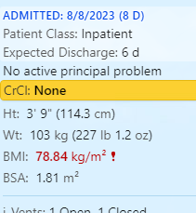

Answering Yes cannot force a function in a flowsheet so Amputation Adjustment may not be filled out. Even if done correctly the Adjusted BMI does not flow to the calculated BMI on the storyboard.

